National Institute of Technology Karnataka, Surathkal

Department of Computer Science and Engineering

CS302 - Computer Networks Lab

Packet Tracer Assignment – Star Topology



Submitted by:

Name: Manas Trivedi  
Roll no.: 181CO231  
Reg. no.: 181711

Odd Semester 2020-2021

Layout of the network before configuration of individual devices,

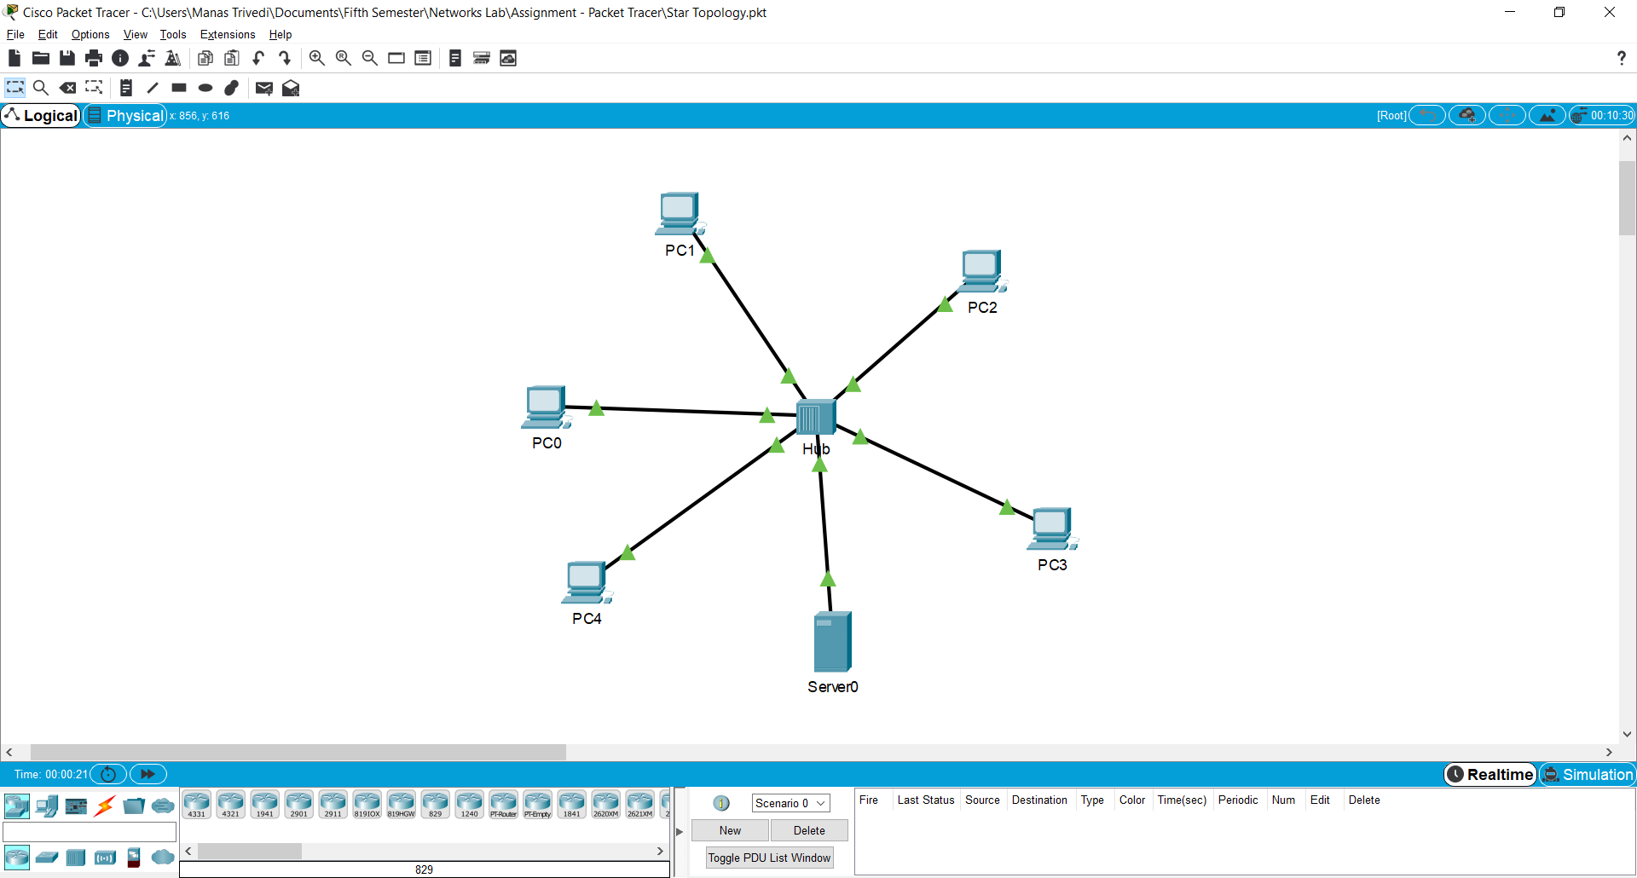

Setting the IP address and subnet mask of Server0,

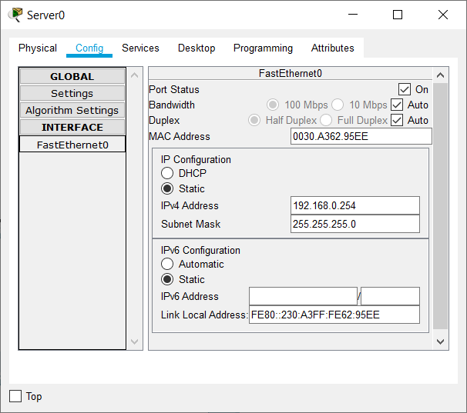

Setting the default gateway and the DNS server for Server0,

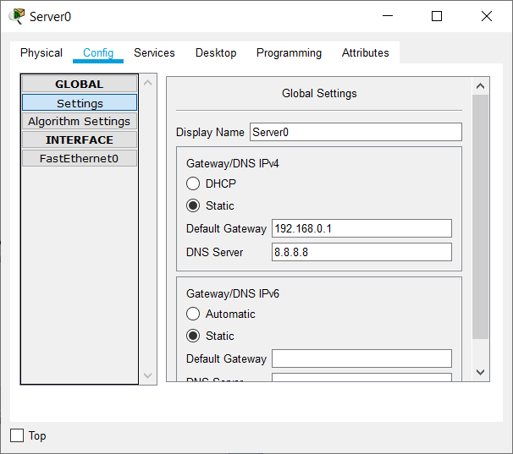

Setting up the DHCP service in Server0,

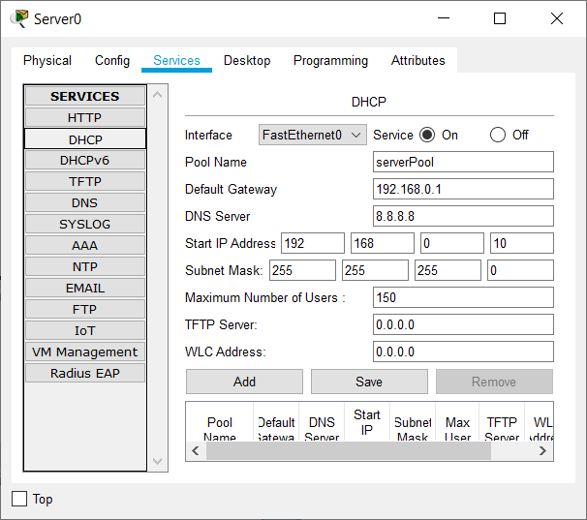

Enabling DHCP in IP configuration for each PC,

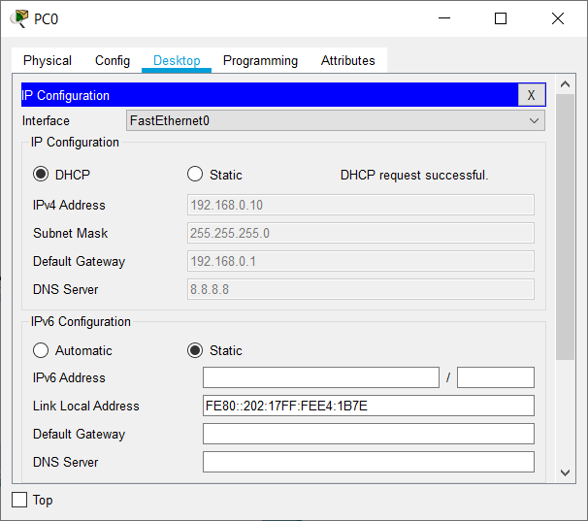 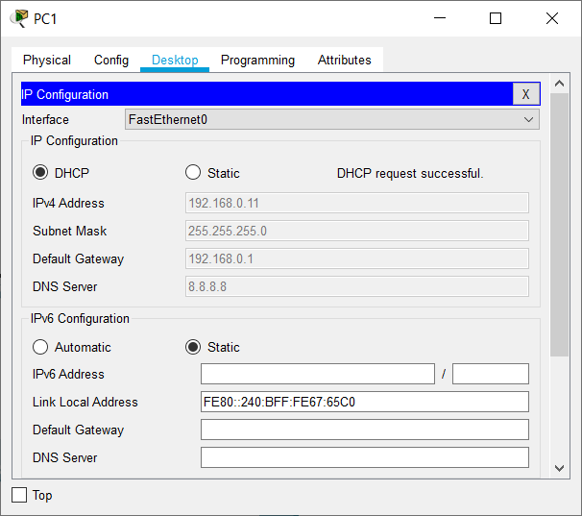 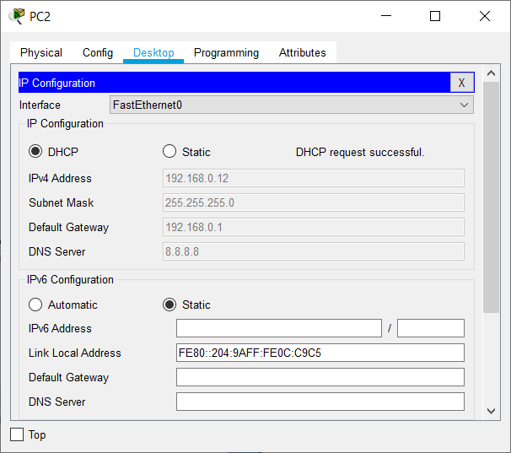

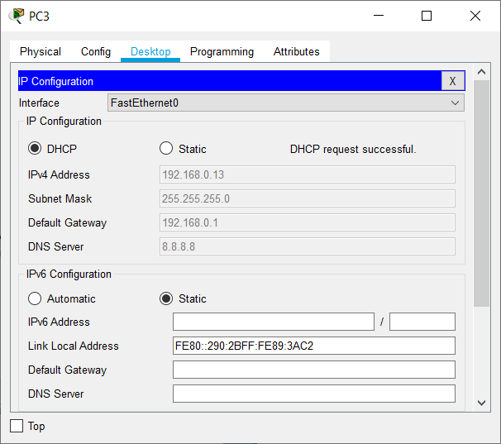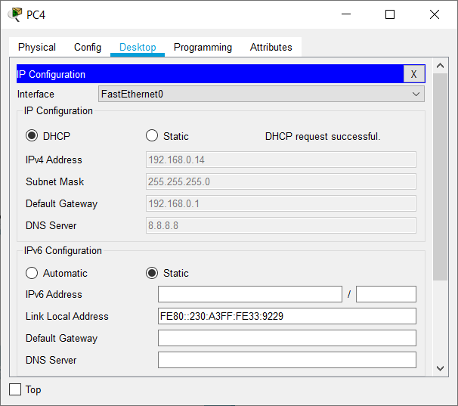

Simulation of sending a ping from PC0 to Server0,

Stage 1: PC0’s ping arrives at Hub

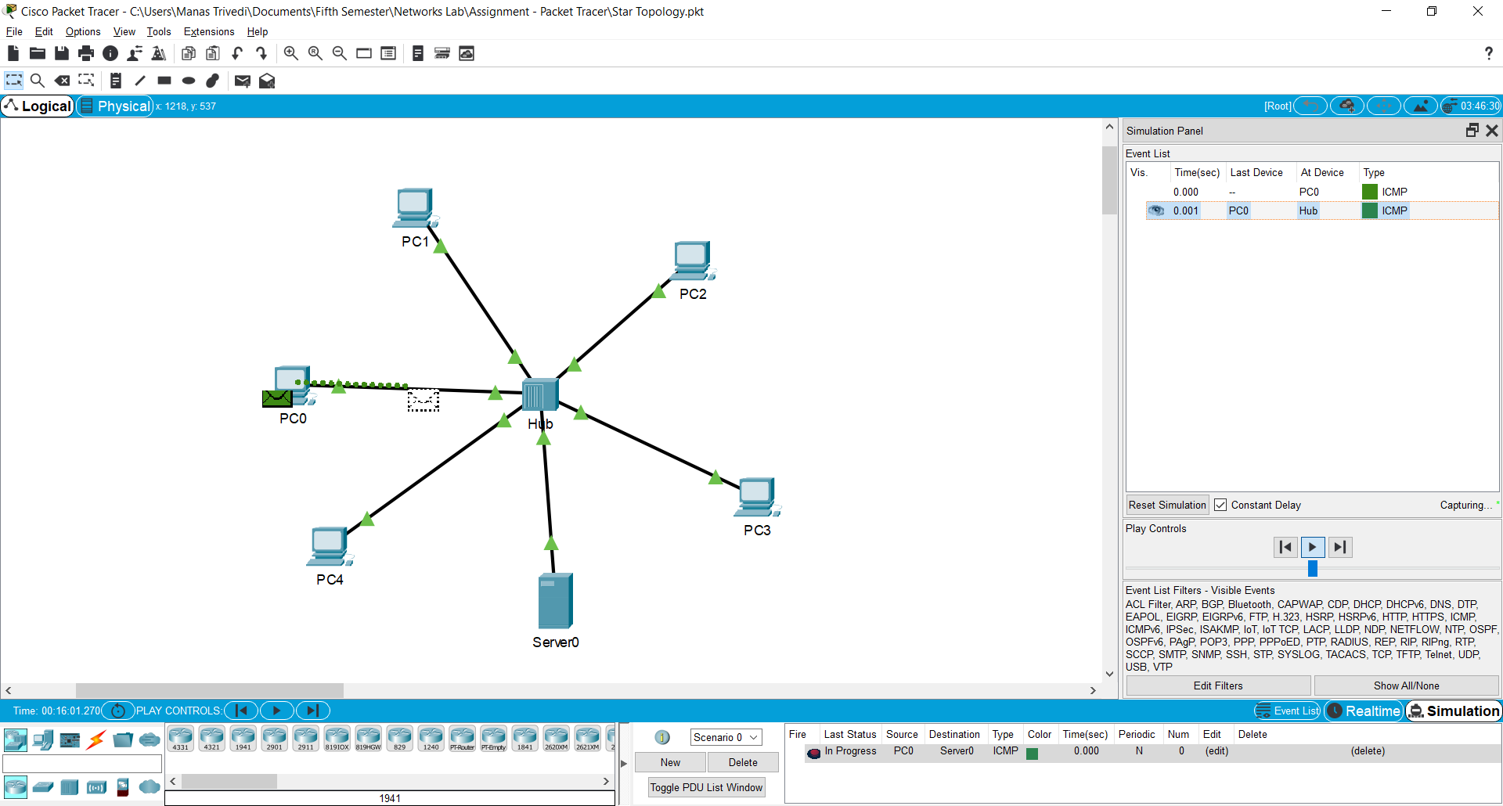

Stage 2: The Hub broadcasts the ping

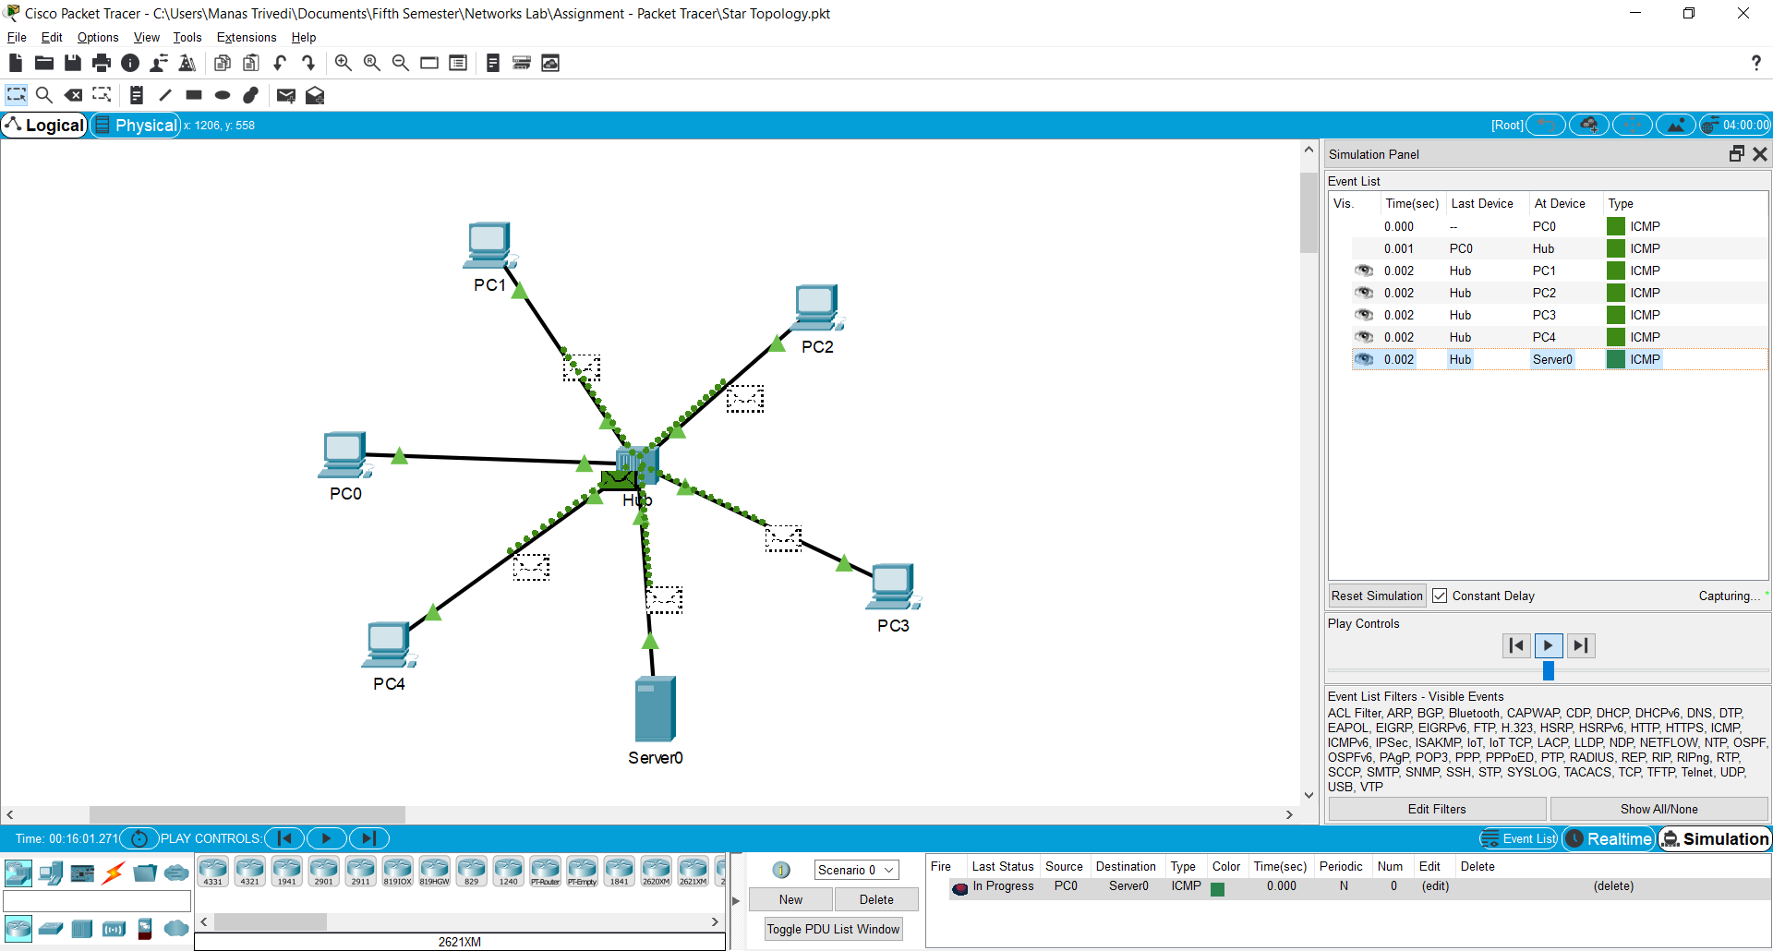

Stage 3: Server0 receives ping

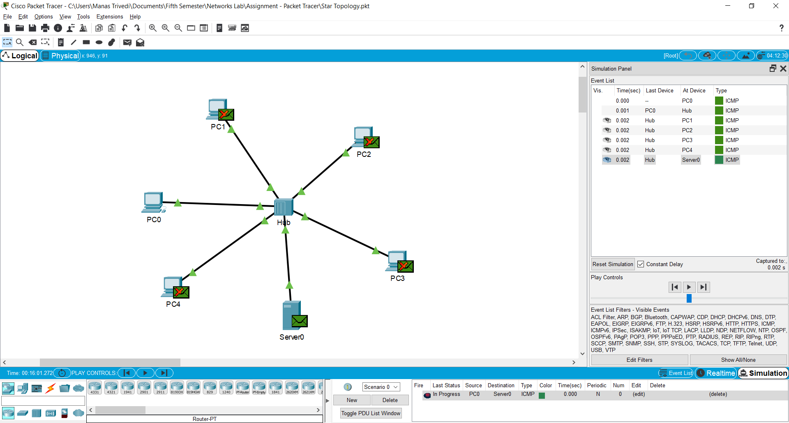

Stage 4: Server0 sends back response

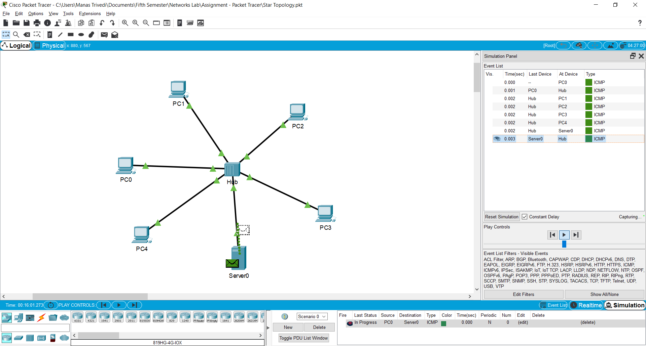

Stage 5: Hub broadcasts the received response

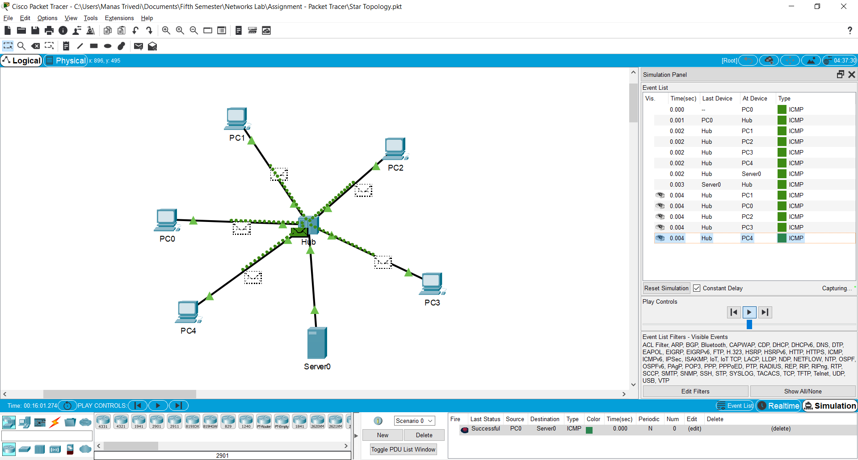

Stage 6: PC0 receives the response

